

**Packet Tracer - Configure IP ACLs to Mitigate Attacks** (Instructor Version)

**Instructor Note**: Red font color or Gray highlights indicate text that appears in the instructor copy only.

## Topology

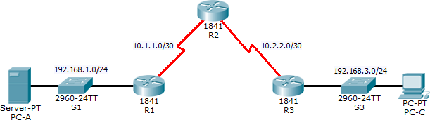

**Addressing Table**

|  |  |  |  |  |  |
| --- | --- | --- | --- | --- | --- |
| **Device** | **Interface** | **IP Address** | **Subnet Mask** | **Default Gateway** | **Switch Port** |
| R1 | Fa0/1 | 192.168.1.1 | 255.255.255.0 | N/A | S1 Fa0/5 |
| S0/0/0 (DCE) | 10.1.1.1 | 255.255.255.252 | N/A | N/A |
| R2 | S0/0/0 | 10.1.1.2 | 255.255.255.252 | N/A | N/A |
| S0/0/1 (DCE) | 10.2.2.2 | 255.255.255.252 | N/A | N/A |
| Lo0 | 192.168.2.1 | 255.255.255.0 | N/A | N/A |
| R3 | Fa0/1 | 192.168.3.1 | 255.255.255.0 | N/A | S3 Fa0/5 |
| S0/0/1 | 10.2.2.1 | 255.255.255.252 | N/A | N/A |
| PC-A | NIC | 192.168.1.3 | 255.255.255.0 | 192.168.1.1 | S1 Fa0/6 |
| PC-C | NIC | 192.168.3.3 | 255.255.255.0 | 192.168.3.1 | S3 Fa0/18 |

**Objectives**

* Verify connectivity among devices before firewall configuration.
* Use ACLs to ensure remote access to the routers is available only from management station PC-C.
* Configure ACLs on R1 and R3 to mitigate attacks.
* Verify ACL functionality.

## Background / Scenario

Access to routers R1, R2, and R3 should only be permitted from PC-C, the management station. PC-C is also used for connectivity testing to PC-A, a server providing DNS, SMTP, FTP, and HTTPS services.

Standard operating procedure is to apply ACLs on edge routers to mitigate common threats based on source and/or destination IP address. In this activity, you create ACLs on edge routers R1 and R3 to achieve this goal. You then verify ACL functionality from internal and external hosts.

The routers have been pre-configured with the following:

* Enable password: **ciscoenpa55**
* Password for console: **ciscoconpa55**
* Username for VTY lines: **SSHadmin**
* Password for VTY lines: **ciscosshpa55**
* IP addressing
* Static routing

# Part 1: Verify Basic Network Connectivity

Verify network connectivity prior to configuring the IP ACLs.

### Step 1: From PC-A, verify connectivity to PC-C and R2.

1. From the command prompt, ping **PC-C** (192.168.3.3).

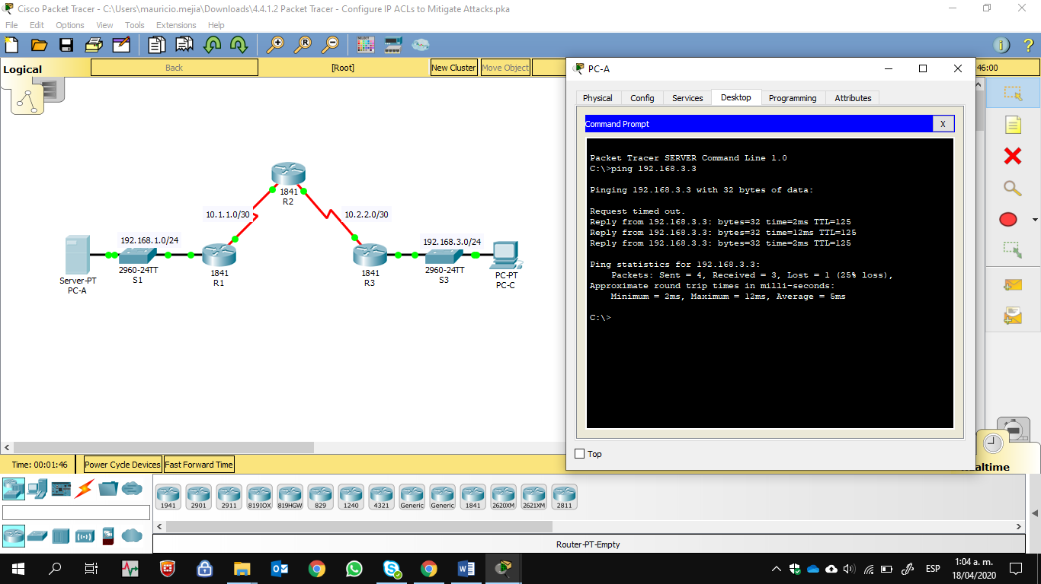

1. From the command prompt, establish a SSH session to **R2** Lo0 interface (192.168.2.1) using username

**SSHadmin** and password **ciscosshpa55**. When finished, exit the SSH session.

#### PC> ssh -l SSHadmin 192.168.2.1

#### 

**Step 2: From PC-C, verify connectivity to PC-A and R2.**

1. From the command prompt, ping **PC-A** (192.168.1.3).

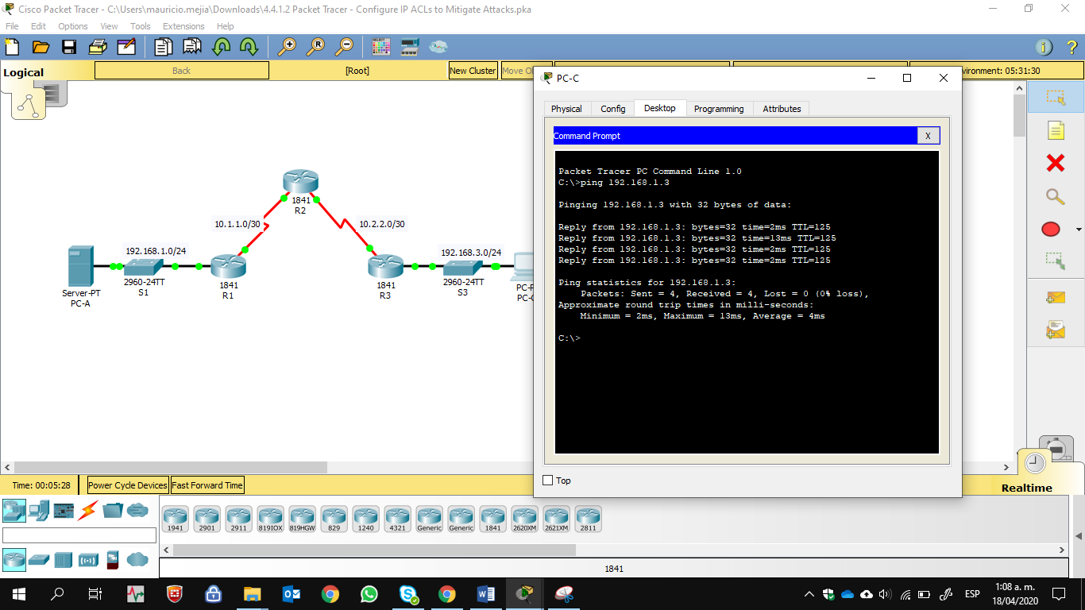

1. From the command prompt, establish a SSH session to **R2** Lo0 interface (192.168.2.1) using username

**SSHadmin** and password **ciscosshpa55**. Close the SSH session when finished.

#### PC> ssh -l SSHadmin 192.168.2.1

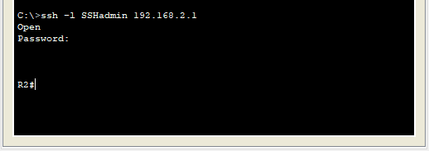

1. Open a web browser to the **PC-A** server (192.168.1.3) to display the web page. Close the browser when done.

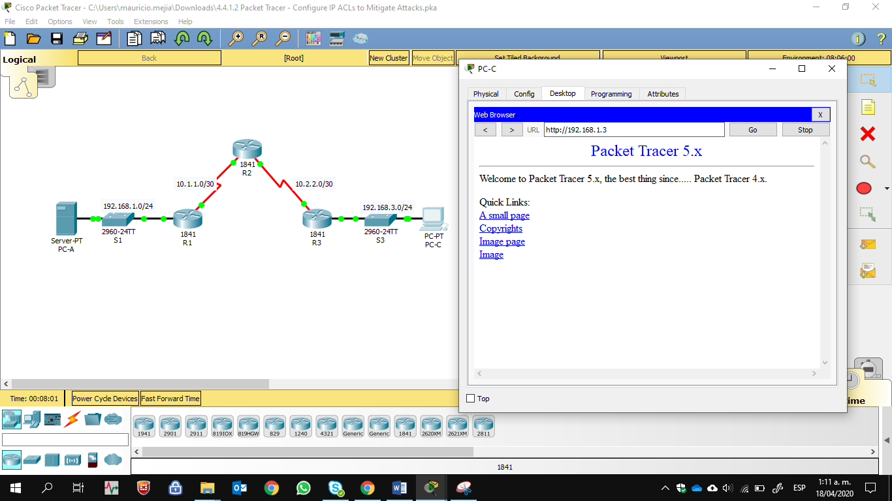

# Part 2: Secure Access to Routers

### Step 1: Configure ACL 10 to block all remote access to the routers except from PC-C.

Use the **access-list** command to create a numbered IP ACL on **R1**, **R2**, and **R3**.

R1(config)# **access-list 10 permit 192.168.3.3 0.0.0.0** R2(config)# **access-list 10 permit 192.168.3.3 0.0.0.0** R3(config)# **access-list 10 permit 192.168.3.3 0.0.0.0**







### Step 2: Apply ACL 10 to ingress traffic on the VTY lines.

Use the **access-class** command to apply the access list to incoming traffic on the VTY lines.

R1(config-line)# **access-class 10 in** R2(config-line)# **access-class 10 in** R3(config-line)# **access-class 10 in**







### Step 3: Verify exclusive access from management station PC-C.

1. Establish a SSH session to 192.168.2.1 from **PC-C** (should be successful).

#### PC> ssh –l SSHadmin 192.168.2.1

#### 

1. Establish a SSH session to 192.168.2.1 from **PC-A** (should fail).

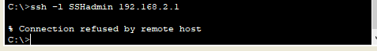

# Part 3: Create a Numbered IP ACL 120 on R1

Permit any outside host to access DNS, SMTP, and FTP services on server **PC-A**, deny any outside host access to HTTPS services on **PC-A**, and permit **PC-C** to access **R1** via SSH.

### Step 1: Verify that PC-C can access the PC-A via HTTPS using the web browser.

Be sure to disable HTTP and enable HTTPS on server **PC-A**.

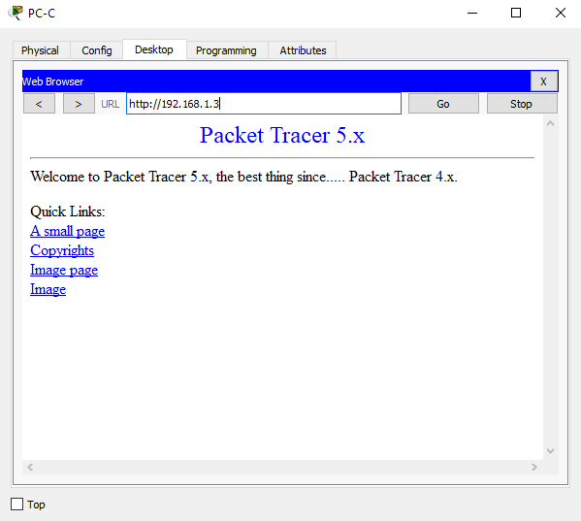

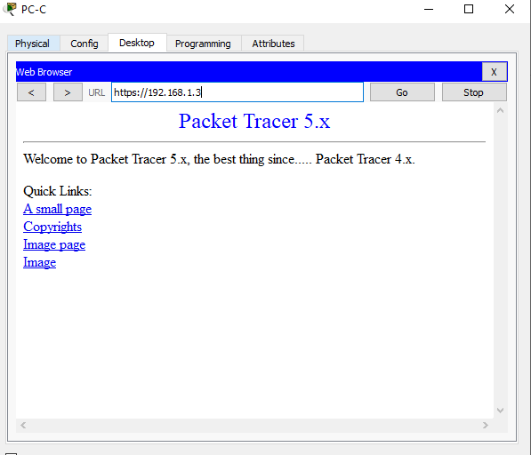

### Step 2: Configure ACL 120 to specifically permit and deny the specified traffic.

Use the **access-list** command to create a numbered IP ACL.

#### R1(config)# access-list 120 permit udp any host 192.168.1.3 eq domain R1(config)# access-list 120 permit tcp any host 192.168.1.3 eq smtp R1(config)# access-list 120 permit tcp any host 192.168.1.3 eq ftp R1(config)# access-list 120 deny tcp any host 192.168.1.3 eq 443 R1(config)# access-list 120 permit tcp host 192.168.3.3 host 10.1.1.1 eq 22

#### 

**Step 3: Apply the ACL to interface S0/0/0.**

Use the **ip access-group** command to apply the access list to incoming traffic on interface S0/0/0.

R1(config)# **interface s0/0/0**

R1(config-if)# **ip access-group 120 in**



### Step 4: Verify that PC-C cannot access PC-A via HTTPS using the web browser.

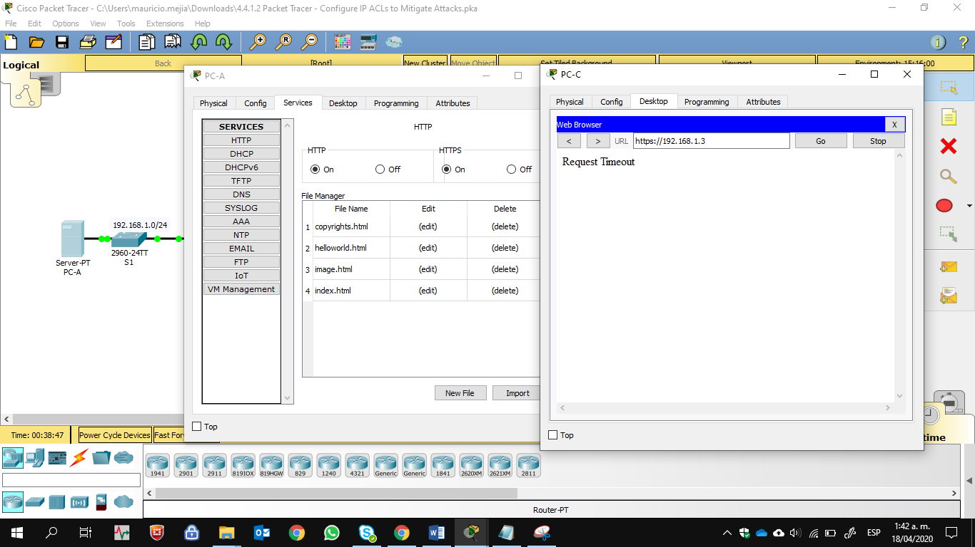

**Part 4: Modify An Existing ACL on R1**

Permit ICMP echo replies and destination unreachable messages from the outside network (relative to **R1**); deny all other incoming ICMP packets.

### Step 1: Verify that PC-A cannot successfully ping the loopback interface on R2.

### 

**Step 2: Make any necessary changes to ACL 120 to permit and deny the specified traffic.**

Use the **access-list** command to create a numbered IP ACL.

R1(config)# **access-list 120 permit icmp any any echo-reply** R1(config)# **access-list 120 permit icmp any any unreachable** R1(config)# **access-list 120 deny icmp any any**

R1(config)# **access-list 120 permit ip any any**

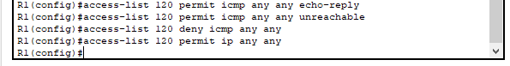

### Step 3: Verify that PC-A can successfully ping the loopback interface on R2.

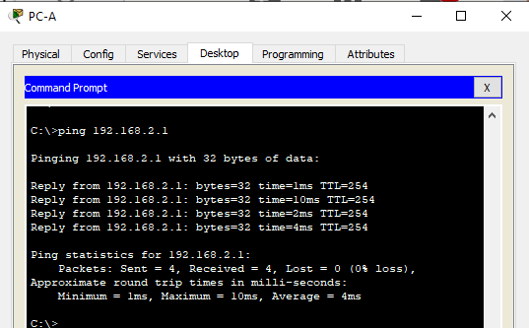

**Part 5: Create a Numbered IP ACL 110 on R3**

Deny all outbound packets with source address outside the range of internal IP addresses on **R3**.

### Step 1: Configure ACL 110 to permit only traffic from the inside network.

Use the **access-list** command to create a numbered IP ACL.

#### R3(config)# access-list 110 permit ip 192.168.3.0 0.0.0.255 any

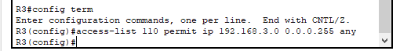

**Step 2: Apply the ACL to interface F0/1.**

Use the **ip access-group** command to apply the access list to incoming traffic on interface F0/1.

R3(config)# **interface fa0/1**

R3(config-if)# **ip access-group 110 in**



# Part 6: Create a Numbered IP ACL 100 on R3

On **R3**, block all packets containing the source IP address from the following pool of addresses: 127.0.0.0/8, any RFC 1918 private addresses, and any IP multicast address.

### Step 1: Configure ACL 100 to block all specified traffic from the outside network.

You should also block traffic sourced from your own internal address space if it is not an RFC 1918 address (in this activity, your internal address space is part of the private address space specified in RFC 1918).

Use the **access-list** command to create a numbered IP ACL.

#### R3(config)# access-list 100 deny ip 10.0.0.0 0.255.255.255 any R3(config)# access-list 100 deny ip 172.16.0.0 0.15.255.255 any R3(config)# access-list 100 deny ip 192.168.0.0 0.0.255.255 any R3(config)# access-list 100 deny ip 127.0.0.0 0.255.255.255 any R3(config)# access-list 100 deny ip 224.0.0.0 15.255.255.255 any R3(config)# access-list 100 permit ip any any

#### 

**Step 2: Apply the ACL to interface Serial 0/0/1.**

Use the **ip access-group** command to apply the access list to incoming traffic on interface Serial 0/0/1.

R3(config)# **interface s0/0/1**

R3(config-if)# **ip access-group 100 in**



### Step 3: Confirm that the specified traffic entering interface Serial 0/0/1 is dropped.

From the **PC-C** command prompt, ping the **PC-A** server. The ICMP echo *replies* are blocked by the ACL since they are sourced from the 192.168.0.0/16 address space.

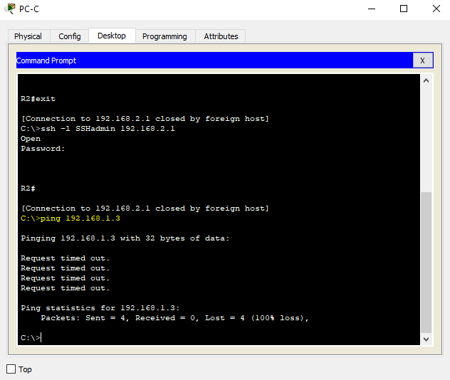

### Step 4: Check results.

Your completion percentage should be 100%. Click **Check Results** to see feedback and verification of which required components have been completed.

**!!!Script for R1**

access-list 10 permit 192.168.3.3 0.0.0.0 line vty 0 4

access-class 10 in

access-list 120 permit udp any host 192.168.1.3 eq domain access-list 120 permit tcp any host 192.168.1.3 eq smtp access-list 120 permit tcp any host 192.168.1.3 eq ftp access-list 120 deny tcp any host 192.168.1.3 eq 443

access-list 120 permit tcp host 192.168.3.3 host 10.1.1.1 eq 22 interface s0/0/0

ip access-group 120 in

access-list 120 permit icmp any any echo-reply access-list 120 permit icmp any any unreachable access-list 120 deny icmp any any

access-list 120 permit ip any any

## !!!Script for R2

access-list 10 permit 192.168.3.3 0.0.0.0 line vty 0 4

access-class 10 in

## !!!Script for R3

access-list 10 permit 192.168.3.3 0.0.0.0 line vty 0 4

access-class 10 in

access-list 100 deny ip 10.0.0.0 0.255.255.255 any access-list 100 deny ip 172.16.0.0 0.15.255.255 any access-list 100 deny ip 192.168.0.0 0.0.255.255 any access-list 100 deny ip 127.0.0.0 0.255.255.255 any access-list 100 deny ip 224.0.0.0 15.255.255.255 any access-list 100 permit ip any any

interface s0/0/1

ip access-group 100 in

access-list 110 permit ip 192.168.3.0 0.0.0.255 any interface fa0/1

ip access-group 110 in

